**Name: Talal Khan**

**Roll No: DT-22043**

**Operating System Lab 3**

**CODE:**

#include <stdio.h>

#include <stdlib.h>

#include <pthread.h>

void *func1(void *ptr);

void *func2(void *ptr);

main()

{

pthread_t thread1, thread2;

char *message1 = "Thread 1";

char *message2 = "Thread 2";

int iret1, iret2;

iret1 = pthread_create( &thread1, NULL, func1,

(

void*) message1);

iret2 = pthread_create( &thread2, NULL, func2,

(

void*) message1);

pthread_join( thread1, NULL);

pthread_join( thread2, NULL);

printf("\n\nThread 1 returns: %d\n",iret1);

printf("\nThread 2 returns: %d\n",iret2);

exit(0);

}

void *func1(void *ptr) {

for (int i = 0; i < 6; i++) {

printf("\nfunc1 %d", i);

sleep(1);

}

}

void *func2(void *ptr) {

for (int i = 0; i < 6; i++) {

printf("\nfunc2 %d", i);

sleep(3);

}

}

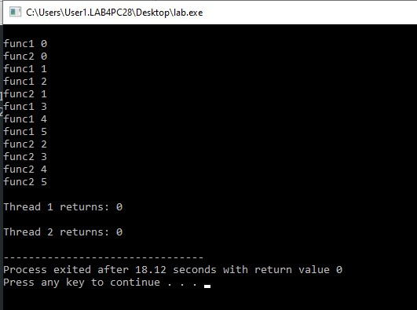

void *func1(void *ptr) {

for (int i = 0; i < 6; i++) {

printf("\nfunc1 %d", i);

sleep(1);

}

}

void *func2(void *ptr) {

for (int i = 0; i < 6; i++) {

printf("\nfunc2 %d", i);

sleep(3);

}

}

**OUTPUT:**